

Artemis Financial
CS 305 Project Two

Table of Contents
Document Revision History 3
Client 3
Instructions 3
Developer 4
1. Algorithm Cipher 4
2. Certificate Generation 4
3. Deploy Cipher 4
4. Secure Communications 4
5. Secondary Testing 4
6. Functional Testing 4
7. Summary 4
8. Industry Standard Best Practices 4

Document Revision History

Version | Date | Author | Comments
1.0 | 12/21/2025 | Phillip Cowan | Submission of Project Two for partial credit

Client



Instructions

Submit this completed practices for secure software report. Replace the bracketed text with the relevant information. You must document your process for writing secure communications and refactoring code that complies with software security testing protocols.

- Respond to the steps outlined below and include your findings.
- Respond using your own words. You may also choose to include images or supporting materials. If you include them, make certain to insert them in all the relevant locations in the document.
- Refer to the Project Two Guidelines and Rubric for more detailed instructions about each section of the template.

Developer
Phillip Cowan

Algorithm Cipher

I selected the AES 256 cipher. Which is using a secure hash function.

Certificate Generation

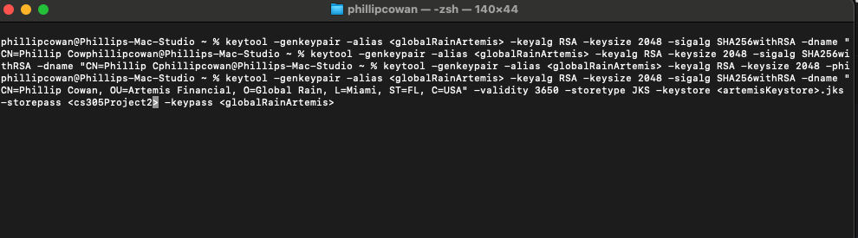
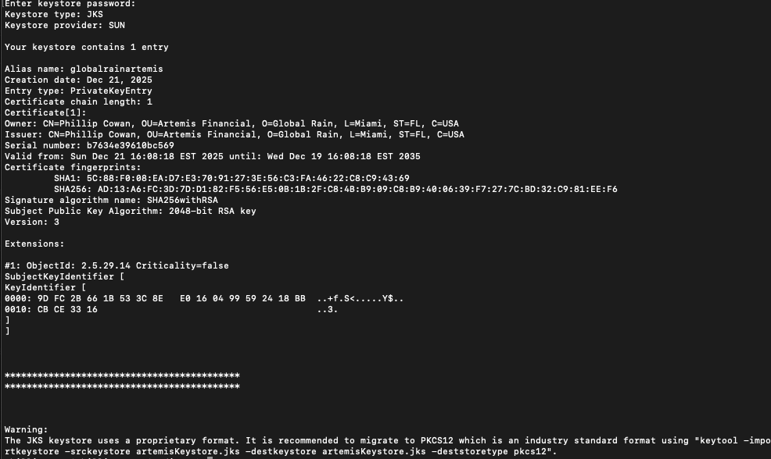

Deploy Cipher
Insert a screenshot below of the checksum verification.

[Insert screenshots here.]

Secure Communications
Insert a screenshot below of the web browser that shows a secure webpage.

[Insert screenshots here.]

Secondary Testing
Insert screenshots below of the refactored code executed without errors and the dependency-check report.

[Insert screenshots here.]

Functional Testing
Insert a screenshot below of the refactored code executed without errors.

[Insert screenshots here.]

Summary

[Insert text.]

Industry Standard Best Practices

[Insert text.]

